**Replace Singletons With Singleton**

|  |  |  |
| --- | --- | --- |
| *many singleton classes complicate the design* |  | *preserve uniqueness of the instances with a singleton and convert the original to ordinary classes* |

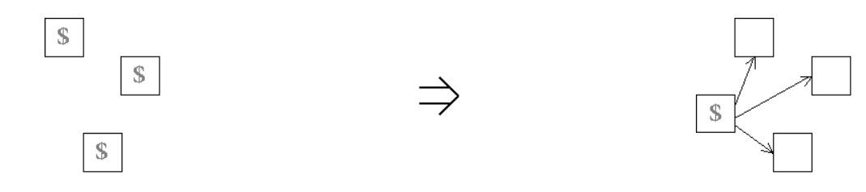

**Context:**  
[Replace Singletons With Singleton](https://web.archive.org/web/20090914101220/http:/www.refactoring.be/thumbnails/rtn-rsws.html) can be seen as a special case of [Introduce Indirection](https://web.archive.org/web/20090914101220/http:/www.refactoring.be/thumbnails/rtn-ii.html) where the indirection serves to preserve the global accessing point while converting the Singletons to regular classes.